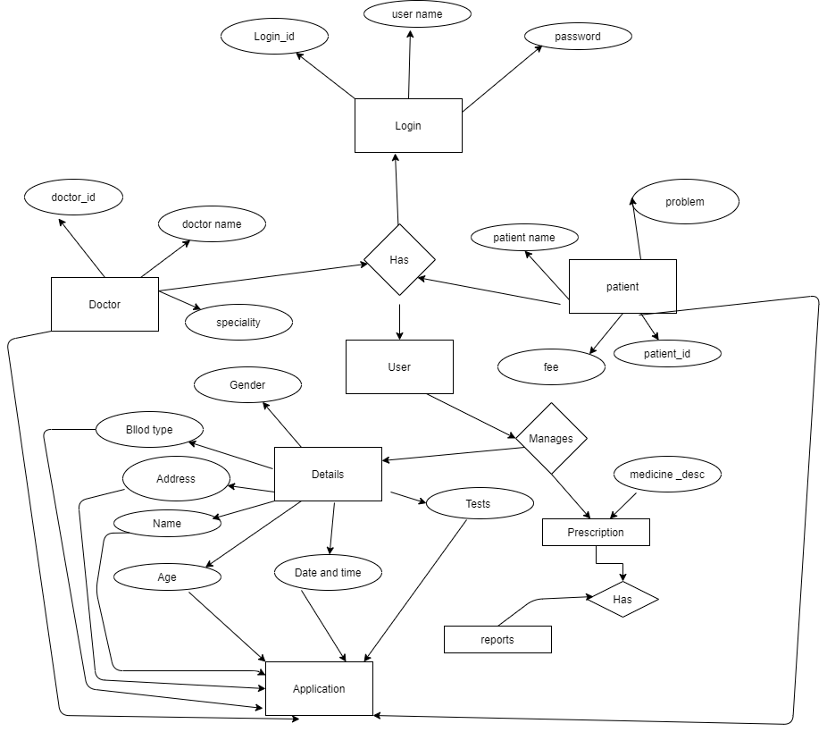

**TABLE 1: LOGIN CREDENTIALS TABLE**

|  |  |  |  |
| --- | --- | --- | --- |
| **LOGIN ID(PK)** | **PATIENT(FK)** | **DOCTOR (FK)** | **PATIENT ID(FK)** |

**TABLE 2: Doctor TABLE**

|  |  |  |  |
| --- | --- | --- | --- |
| **Doctor ID(PK)** | **Doctor Name** | **Specialization** | **Patient Id(Fk)** |

**TABLE 3: Patient TABLE**

|  |  |  |  |  |  |  |  |
| --- | --- | --- | --- | --- | --- | --- | --- |
| **PATIENT ID(PK)** | **Doctor Id(FK)** | **NAME** | **AGE** | **GENDER** | **Problem** | **ADDRESS** | **Appointment DATE &TIME** |

**TABLE 4: User Table**

|  |  |  |  |
| --- | --- | --- | --- |
| **User ID(PK)** | **PATIENT ID(FK)** | **Doctor ID(FK)** | **Appointment DATE AND TIME** |

**TABLE 5 : Tests TABLE**

|  |  |  |  |
| --- | --- | --- | --- |
| **Test ID(PK)** | **Patient Id(FK)** | **Doctor ID(FK)** | **Test DATE AND TIME** |

**TABLE 6 : Medicines TABLE**

|  |  |  |  |
| --- | --- | --- | --- |
| **Medicine ID(PK)** | **Patient Id(FK)** | **Doctor ID(FK)** | **Amount** |